How to setup timer of Tenda Smart Plug in Beli APP?

Beli APP is designed to control Tenda Smart Plug locally and also remotely. With Beli app, we can easily control and monitor Tenda Smart Plug wherever we are and make our home smart.

Step1: On the Beli app, go to Devices page, click on SP3, then tap Schedule icon.

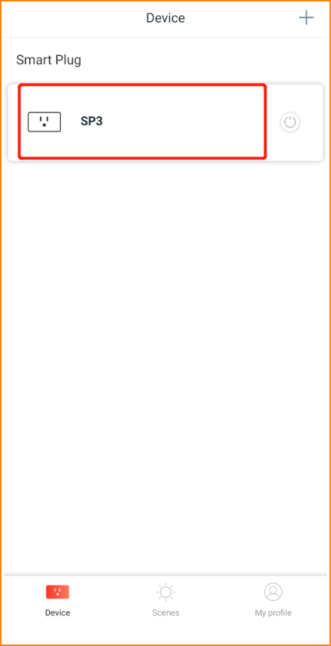
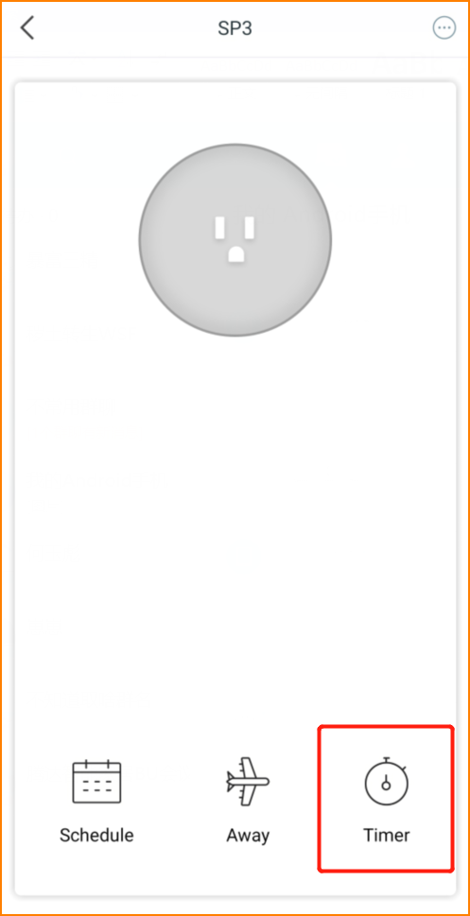

Step2: Set the time and the status of smart plug. Then click “Save”. Take the picture below for example, the SP3 will turn on in 30 minutes.

